.
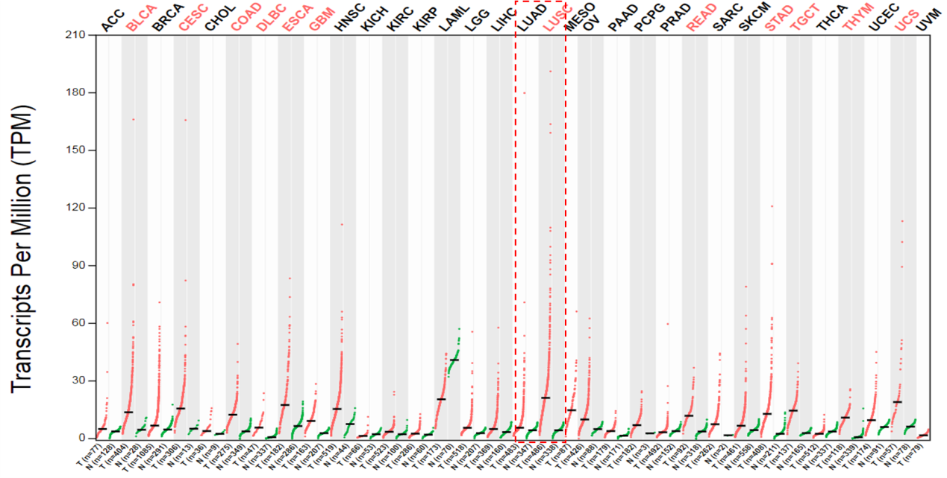
Figure S1. The expression level of Skp2 in various cancer types was analyzed by online database (http://gepia.cancer-pku.cn/detail.php?gene=SKP2).

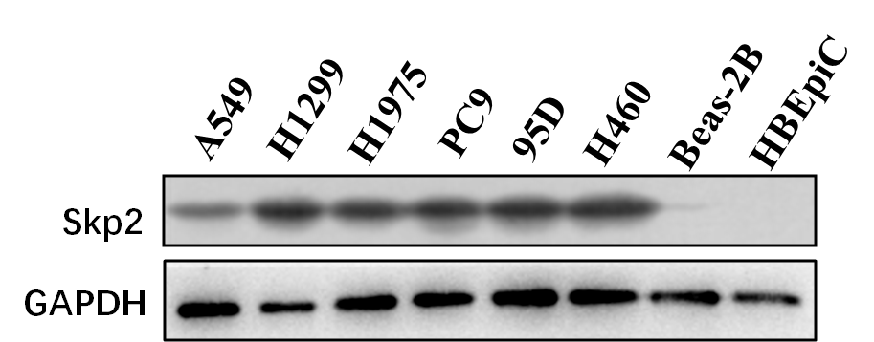
Figure S2. Skp2 protein expression was examined in NSCLC cells and normal bronchial epithelial cells.

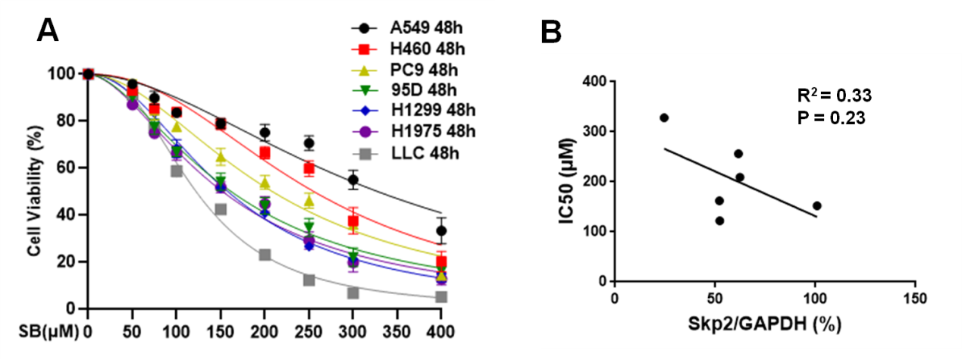
Figure S3. Skp2 expression has a weak association with SB sensitivity in NSCLC cells. A. IC50 values of SB in NSCLC cells were calculated by Graphpad software. B. Logistic regression analysis was performed and Pearson value was calculated to assess the association between Skp2 protein expression (Figure S2) and SB sensitivity (Figure S3A) in NSCLC cells.

